Participating in The Million Mile Virtual Fundraiser
with Staff, Students, and Families

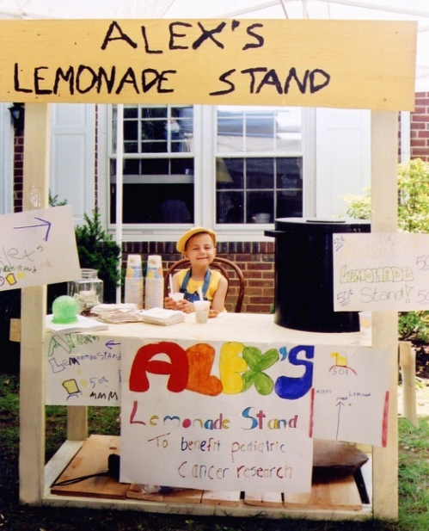
About The Million Mile Virtual Fundraiser
The Million Mile is an annual event in support of Alex's Lemonade Stand Foundation (ALSF). During The Million Mile, teams nationwide join together for Childhood Cancer Awareness Month, September, to log 1,000,000 miles of activity, and raise $1,000,000.
Why join The Million Mile? Bring a common cause to your district, school, or classroom; share the value of philanthropy, and how kids can help kids. Your students can set their own goals – to raise $100, to join a school-wide walk, to wear yellow to raise awareness for childhood cancer - and work towards them together.

How do I participate? Register your team and choose your level of involvement. For a simple addition to your day or school – Send students home with calendars to log their activity for homework; have them raise money at home. For a more involved strategy – incorporate Million Mile into your day or lesson plans; have students reflect on their progress through ‘Do Now’ tasks, or have school assemblies and awareness days to build your school or classroom culture.

About Alex’s Lemonade Stand Foundation

Alex’s Lemonade Stand Foundation (ALSF) is a national childhood cancer foundation dedicated to raising funds for research into new treatments and cures for all children battling cancer and providing support to families of children with cancer.
ALSF was founded by four-year-old Alex Scott, who was diagnosed with cancer shortly after her 1st birthday. She started selling lemonade in her front yard and would go on to raise more than $1 million before she passed away at the age of 8 in 2004.
Today, the movement she started has become one of the largest national pediatric cancer organizations in the United States, having raised more than $150 million towards Alex’s dream of finding a cure, funding over 800 research projects at hospitals across the country.

There are many ways to incorporate The Million Mile into your school this September. Please see the next page for some Common Core State Standards-aligned ideas in Mathematics!

ALEX'S LEMONADE STAND FOUNDATION FOR CHILDHOOD CANCER

Grade | Domain | CCSS Standard(s) | Classroom Application Ideas
K | Counting & Cardinality | Know number names and the count sequence.  CCSS.MATH.CONTENT.K.CC.A.1  Count to 100 by ones and by tens.  CCSS.MATH.CONTENT.K.CC.A.2  Count forward beginning from a given number within the known sequence (instead of having to begin at 1). | Recording weekly progress among all class members by hanging cutouts of shoes or footprints, and counting as a group on a regular basis
 | Operations & Algebraic Thinking | Understand addition as putting together and adding to, and understand subtraction as taking apart and taking from.  CCSS.MATH.CONTENT.K.OA.A.1  Represent addition and subtraction with objects, fingers, mental images, drawings, sounds (e.g., claps), acting out situations, verbal explanations, expressions, or equations.  CCSS.MATH.CONTENT.K.OA.A.2  Solve addition and subtraction word problems, and add and subtract within 10, e.g., by using objects or drawings to represent the problem. | Partners adding their daily miles by using objects or drawings to represent each participants’ progress  Presenting scenarios where a participant walks with their pet on a given day, so two sets of miles are added
1 | Operations & Algebraic Thinking | Represent and solve problems involving addition and subtraction.  CCSS.MATH.CONTENT.1.OA.A.1  Use addition and subtraction within 20 to solve word problems involving situations of adding to, taking from, putting together, taking apart, and comparing, with unknowns in all positions, e.g., by using objects, drawings, and equations with a symbol for the unknown number to represent the problem.  CCSS.MATH.CONTENT.1.OA.A.2  Solve word problems that call for addition of three whole numbers whose sum is less than or equal to 20, e.g., by using objects, drawings, and equations with a symbol for the unknown number to represent the problem. | Adding multiple days’ miles together, individually or among partners  Determining the difference between two weekly totals; how many more miles were completed through one activity than another; or the difference between progress versus goal

Add and subtract within 20.
CCSS.MATH.CONTENT.1.OA.C.6
Add and subtract within 20, demonstrating fluency for addition and subtraction within 10.
2 | Number & Operations in Base Ten | Use place value understanding and properties of operations to add and subtract.  CCSS.MATH.CONTENT.2.NBT.B.5  Fluently add and subtract within 100 using strategies based on place value, properties of operations, and/or the relationship between addition and subtraction.  CCSS.MATH.CONTENT.2.NBT.B.6  Add up to four two-digit numbers using strategies based on place value and properties of operations. | Combining weekly or monthly totals in small groups  Combining totals and then subtracting progress from goal throughout the month  Completing addition and subtraction word problems with various scenarios, such as adding miles from walking + biking + swimming + running, or four weeks of totals for one participant
3 | Operations & Algebraic Thinking | Represent and solve problems involving multiplication and division.  CCSS.MATH.CONTENT.3.OA.A.1  Interpret products of whole numbers, e.g., interpret 5 × 7 as the total number of objects in 5 groups of 7 objects each. For example, describe a context in which a total number of objects can be expressed as 5 × 7.  CCSS.MATH.CONTENT.3.OA.A.2  Interpret whole-number quotients of whole numbers, e.g., interpret 56 ÷ 8 as the number of objects in each share when 56 objects are partitioned equally into 8 shares, or as a number of shares when 56 objects are partitioned into equal shares of 8 objects each. For example, describe a context in which a number of shares or a number of groups can be expressed as 56 ÷ 8. | Word problems:  - Setting monthly goal by multiplying daily goal by 7 and weekly goal by 4  - Predicting individual or class-wide totals by multiplying weekly progress by 4  - Dividing a monthly goal by 4 for weekly goal and then by 7 for daily goal  - Adding 3 group members’ progress, then subtracting this number from a given total to find out the progress of the 4th group member  - Writing applicable word problems and challenging other groups to solve them

Solve problems involving the four operations, and identify and explain patterns in arithmetic.
CCSS.MATH.CONTENT.3.OA.D.8
Solve two-step word problems using the four operations. Represent these problems using equations with a letter standing for the unknown quantity. Assess the reasonableness of answers using mental computation and estimation strategies including rounding.
4 | The Number System | CCSS.MATH.CONTENT.4.NBT.A.3  Use place value understanding to round multi-digit whole numbers to any place. | Rounding progress or totals on a classroom, school, district, or state level
5 | The Number System | CCSS.MATH.CONTENT.5.NBT.A.4  Use place value understanding to round decimals to any place. | Rounding progress on an individual level, per day, week, or month
 | Number & Operations in Base Ten | Understand the place value system.  CCSS.MATH.CONTENT.5.NBT.A.1  Recognize that in a multi-digit number, a digit in one place represents 10 times as much as it represents in the place to its right and 1/10 of what it represents in the place to its left.  CCSS.MATH.CONTENT.5.NBT.A.2  Explain patterns in the number of zeros of the product when multiplying a number by powers of 10, and explain patterns in the placement of the decimal point when a decimal is multiplied or divided by a power of 10. Use whole-number exponents to denote powers of 10. | Dividing multiples of 10 into 1,000,000  Multiplying a daily, weekly, monthly, group-wide, class-wide, or other total by a power of 10 to come as close as possible to one million
6 | Ratios & Proportional Relationships | Understand ratio concepts and use ratio reasoning to solve problems.  CCSS.MATH.CONTENT.6.RP.A.1  Understand the concept of a ratio and use ratio language to describe a ratio relationship between two quantities. | Predicting or calculating pledge totals for given team members, or formulating an idea for a suggested pledge amount based on participant goals
 | Expressions & Equations | CCSS.MATH.CONTENT.6.EE.B.6  Use variables to represent numbers and write expressions when solving a real-world or mathematical problem; understand that a variable can represent an unknown number, or, depending on the purpose at hand, any number in a specified set. | Calculating donation totals from pledge amounts
7 | Ratios & Proportional Relationships | Analyze proportional relationships and use them to solve real-world and mathematical problems.  CCSS.MATH.CONTENT.7.RP.A.2  Recognize and represent proportional relationships between quantities. | Identifying the pledge amount as the constant and the distance logged as the variable in an equation  Calculating potential donations based on various distances, either on its own or as part of setting individual goals
8 | Geometry | Understand and apply the Pythagorean Theorem.  CCSS.MATH.CONTENT.8.G.B.7  Apply the Pythagorean Theorem to determine unknown side lengths in right triangles in real-world and mathematical problems in two and three dimensions. | Determining the length of one leg of a (hypothetical) exercise path after being given the length of the other two sides
 |  | Understand the connections between proportional relationships, lines, and linear equations.  CCSS.MATH.CONTENT.8.EE.B.5  Graph proportional relationships, interpreting the unit rate as the slope of the graph. Compare two different proportional relationships represented in different ways. For example, compare a distance-time graph to a distance-time equation to determine which of two moving objects has greater speed. | Writing and solving word problems to determine which participant in each scenario is exercising at a faster speed, or which will travel a further distance in a certain amount of time at a certain level of speed.

