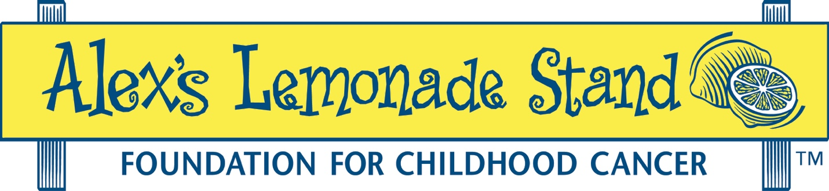

ALSF Resource Sharing Form and Guidelines

Page 1 - Application Requirements

Page 2 - Sample & Review Rubric

Questions regarding the Resource Sharing application section or review criteria can be directed to Grants@AlexsLemonade.org.

Application Resource Sharing Section: Track Record and Plan

Application reviewers will be asked to consider the manner in which resources will be shared and the extent to which that plan, as well as the investigator’s track record* of sharing useful outputs, will increase or decrease the impact of the proposed project. This will depend on the extent to which sharing enhances or diminishes the perceived value of the work.

- Complete relevant categories for unique research outputs expected from this grant.
- Delete unused categories; use “Other” for additional categories.
- You should delete the instruction text in italics when completing this form.
- Copy and insert the completed form into the Resource Sharing section of the application outline.

*Early Career investigators applying for Young Investigator, ‘A’ Award or Psychosocial Launch grants are encouraged to describe past experience; however, it is understood this may be limited. The review will focus on how you would share outputs from this project.

FORM (1-page maximum)

Data Sharing:
- Highlight how you have shared data publicly – i.e., not upon request – and how those data have been reused. Illustrate with reuse metrics such as citation counts, downloads, or other such data if available.
- Discuss how you plan to share the outputs from this proposal and how the data will be archived (via the recognized repository for the type of data or, for data without such a repository, via Zenodo, FigShare, or similar archival services). How will data be licensed (i.e., CC0 or another license). You must discuss how and when data that you generate during the course of this project will be shared. If access will be controlled via a data access committee or other such structure, describe the conditions under which data will be shared and specify how relevant metrics (number of requests made, number of requests approved, time to respond to requests) will be stored and reported to us and the scientific community.
Protocol Sharing:
- Highlight how you have shared protocols openly – i.e., not upon request – and how those protocols have been used by others. For example, you may have posted them to protocols.io or a similar service.
- Discuss how and when you plan to share the outputs from this proposal. Not all projects will result in protocols. If yours does not, this section can be deleted.
Material and Reagent Sharing:
- Highlight how you have shared materials and reagents and how those reagents have been reused.
- Discuss how and when you plan to share the reagents and materials developed in your group as part of the proposal (e.g. deposit plasmids in Addgene, deposit cell lines in the appropriate cell bank). Not all projects will produce new materials and reagents. If yours does not, this section can be deleted.
Source Code Sharing:
- Highlight how you have shared source code, software, and computational workflows openly – i.e., not upon request – and how the source code has been used by others. For example, you may have uploaded them to GitHub or a similar service.
- Discuss how and when you plan to share the outputs from this proposal. How will software be licensed (i.e., MIT or another license)? Are there plans to produce a polished software package? If so, how will that be distributed? Not all projects will result in source code. If yours does not, this section can be deleted.
Other Outputs:
- Highlight how you have shared other outputs and how those outputs have been used by others.
- Discuss how and when you will share other expected outputs from this work.
Clinical Trials Reporting: If you propose a clinical trial discuss how you will maintain up to date records on the relevant repositories (e.g., clinicaltrials.gov). Discuss the trials you have run in the past and the extent to which those records have been maintained. Please provide links.

Resource Sharing Example:

Data Sharing: In previous projects, we performed gene expression analysis of treated and untreated cell lines. We uploaded our data to NCBI’s GEO repository at the time the data were collected, and we made these data openly available with the publication of our manuscript [1]. In GEO these have been assigned the identifiers GSE1245, GSE1246, and GSE1247. We annotated these data with treatment date, processing batch, cell line, and treatment type. These data were downloaded and reanalyzed by Doe et al. [2] and Smith et al. [3] to identify additional targets. These data were integrated into a larger analysis of multiple datasets by Patel et al. [4]. In this project we will perform RNA-seq analysis of XYZ cell lines. We will upload sequencing data to SRA and link the raw data to summary information in NCBI’s GEO repository. We will annotate experimental metadata using terms from the Experiment Factor Ontology (EFO) where relevant terms are available. We will make these data publicly available to the community at the time of publication.

Rubric for Reviewers:
Please use the full range of scores (1-9) for this criterion. We expect that very few applications will receive a perfect score in this area.

General Track Record:
- Do the applicants have a track record of sharing resources that are remarkable for their richness, granularity, or quality such that those resources are particularly inviting to people who wish to use them.
- Do the applicants have a track record of sharing resources in a manner that is as easy as possible for people to re-use within ethical and legal constraints.
- Have the applicants shared resources that have already been reused by other investigators to answer a new question?
- Early Career Grants: Young Investigator, ‘A’ or Psychosocial Launch. Applicants are encouraged to describe past experience; however, it is understood they may not have a track record. The reviewer should focus on the Sharing Plan.

General Resource Sharing Plan:
- Do the authors use an established repository for the resource? (See AHA guidelines on repositories for questions https://goo.gl/2UCZ43). A lab website is not acceptable.)
- Is the resource distributed in a way that maximally facilitates reuse?
- Will the resource as described have sufficient metadata available to promote reuse?
- For resources that must be maintained, is there a plan in place to maintain the resource?

Data Sharing:
- Public, widely-used repositories should be used if possible (e.g., GEO or ArrayExpress for gene expression data, SRA for RNA-Seq data, etc.).
- If no public, widely-used repository is available for the data type in question, a general purpose archival repository (e.g., FigShare, Zenodo) should be used.
- For more detailed discussion, the guidelines provided by F1000 research for authors are an excellent resource: https://f1000research.com/for-authors/data-guidelines
- If authors or reviewers have questions, please feel free to contact the Childhood Cancer Data Lab (ccdl@alexslemonade.org) which is happy to seek available options.

Materials and Reagents:
- Public, widely-used repositories (Addgene, cell banks, etc.) should be used if possible.
- On request should be avoided if possible. If distribution will occur upon request, specify the expected response time for the resource, how the response time will be measured, how it will be discussed in progress reports, and how sharing will happen after the grant.
- If the lab will be maintaining the material or reagent, methods that can be used to authenticate the reagent should be specified. When the authentication will occur and who is responsible (distributor, recipient) should also be specified.

Protocols:
- How protocols will be distributed should be specified.
- How protocols will be maintained and clarified should be specified.
- If there exists an appropriate service (e.g., protocols.io) it should be used. Lab websites should generally not be used to distribute protocols.

Source Code:
- Source code should be stored in a version control system and made available through a version control service (e.g., GitHub, Bitbucket, or similar).
- Source code should be archived to an archival service (e.g., Zenodo) at the time of submission and the conclusion of the grant.
- A license should be specified.

